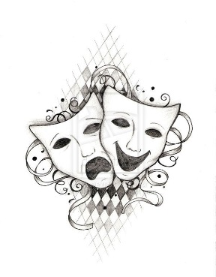
RHS Beg. Theatre Arts
Course Syllabus
Instructor: Ms. Shelby Winter
Room: 1309
Website: rolesvilletheatre.weebly.com
E-mail: swinter@wcpss.net
Course Description
This course is designed to introduce students to the basic fundamentals and building blocks of acting and stage craft.

Students will:
- Work as an Ensemble
- Design and teach warmups
- Practice basic acting skills such as stage movement, voice, and character development/analysis
- Study and use basic theatre terms
- Practice proper rehearsal and audience etiquette
- Develop time management skills
- Study the history of Western Theatre through Performance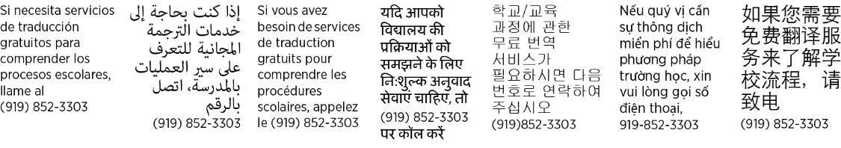
Materials
- Paper
- Pencils
- Movement Clothes
- 1” Three Ring Binder (An equivalent storage device is acceptable but it will be used for notebook checks)
- Possible costume pieces
Requested Items
Parents are more than welcome to donate some much needed classroom items: band aides, tissue, hand sanitizer, antiseptic wipes and creams, paper towels, Swiffer wet jet pads and cleaning fluid.
Grading
- 40% Performance Skills
Performances serve as a demonstration of the skills learned in each unit and are graded through rubrics.

- 30% Skills and Artistic Work Habits
This will show up on PowerSchool as AWH. Students earn 20 points each day based on Artistic Work Habits. Points are added together at the end of each week. To see more details on how a student can earn these points look to Artistic Work Habits section of syllabus.

- 15% Tests and Projects
- 10% Quizzes/Journals
- 5% Classwork/Homework
Important Dates
- Nov. 14th Fall Play Dress Rehearsal (Beginning Theatre Students may attend for free)
- Dec. 15th Final In Class Performance of Oedipus Rex (No makeup dates. Absent students must complete 5 page research paper as a makeup assignment)
- Jan. 5th Critique of Live Performance Paper Due.
BYOD
This year the school is initiating a Bring Your Own Device policy. This policy includes smartphones, tablets, and laptops. Theatre Arts classes are mostly physical in nature so students will be asked to turn off and store their devices for most of, if not all of, my class. Non-compliance with BYOD guidelines could result in having a device locked in a secure location for the remainder of class.
Late Work Policy
The Performing Arts Department will comply with the RHS Policy for Late Work as stated in the Handbook. The Performing Arts Department will accept late work at a penalty of 5 percent off the grade earned for each school day the assignment is late. All assignments must be turned in by the quarter dates determined by Rolesville High School which are listed in the Handbook. Late work cut-off dates are: 9/15, 10/23, 12/4, 1/4, 2/16, 3/21, 5/1, 5/25
Make Up Work
Retest Policy:
Written tests may be made up by quarter dates listed by Rolesville High School.

Make Up Work (in accordance with the RHS Handbook):
For absences of one to three days, the student will have one day for each day absent to complete makeup work.

For absences exceeding three days, the student will have two days for each day absent to complete makeup work.

Absences due to approved school trips are excused. It is the STUDENT’S responsibility to secure such assignments BEFORE a known field trip and in accordance with Handbook, all work will be due upon the student’s return to school during the class period in which the work was assigned.

Missed assignments will not be excused, unless they involve tasks that could only be completed on the particular day an activity was assigned. In such a case, the student will be omitted from that individual assignment (unless an alternate assignment is assigned to take the place of the missing grade).
Performances

Public performance is one of the most effective means of performing arts education assessment. Because chorus, band, orchestra, theatre and dance are considered academic classes, grades are assigned for participation in all scheduled performances. Unexcused absences from any of these events will result in a failing performance grade. Regularly scheduled performances will be graded events, counting 40% of the student's quarter grade assessed on the following criteria:
- Proper preparation: Correct outfit, on-time, present for warm ups with group
- Appropriate energy/attitude
- Focus and teamwork ethic (especially before performance and during transitions)
- Off-stage etiquette
- Performance Assessment and Reflections

All reasons for absences will be considered excused or unexcused at the discretion of the director. A noticeable effort must be made to notify the director BEFORE a concert if a student is going to miss. Acceptable forms of notification will be parental/ guardian phone call, email or written note.
Students may not miss performances without:
o Previous notice and director consent
o Completion of a make-up assignment within 5 days of the missed performance (if absence is previously excused)
If a student is absent from school (due to illness) on the day of an after school performance, he/she is encouraged (if feeling better) to attend the performance as an audience member and write a critique of the performance due the next day that the student is in school. A signed note from a parent, stating that his/her child was sick is necessary to allow the grade substitution. Otherwise, students who miss performances due to illness must bring in a signed note from a parent (stating illness) and complete an alternate assignment to make up the considerable grade.
**According to WCPSS Board Policy, students in OSS, ISS or are not in school a FULL day on the day of a concert ,or other performance, are prohibited from participating in that performance. Such students will have to make the grade up through an individually assigned activity or take a zero.**
Performances in Theatre will take place in class and can be done on an alternate date if it is was a solo performance and absence is excused. December 15 is the classes final performance and falls fully under the policy stated above.
Performance Critique
- Students will be required to see 1 LIVE performance this semester
- The performance may be professional or amateur
- Students must write a 2 page performance review and turn it in by January 5th
- The review must be typed and double spaced
- It will fall under the Tests and Projects category, and will be weighted 15%
- On November 14th Beginning Theatre students will be given the option to stay after school and watch the Final Dress Rehearsal of RHS Theatre Department’s Fall Show free of charge, to aide in fulfilling this requirement
- Performances by other performing arts classes at RHS such as orchestra, dance, chorus or band may be used to fill this requirement; but may not be free.
Artistic Work Habit Expectations
- Student is present and participating everyday
- If student is present but unable to participate due to illness or injury a makeup assignment must be completed in class to receive points
- Student walks into class and immediately begins to prepare for the day’s work
- Student places bags in designated area of the room
- Student keeps any cell phones, headphones or other electronic devices in bag unless otherwise instructed by the teacher
- Student helps with any class set up or clean up throughout lesson
- Student strives to present a positive attitude towards self, activities and others at all times
- Student comes to class fully prepared with theatre notebook, pencils, paper, movement clothes and any scripts or handouts needed for the activity
- Student spits out any gum upon entry to class to prevent choking hazards
- Student leaves any food or drinks (other than water) outside of classroom
- Student is respectful of themselves and the class as a whole
- Student uses rehearsal time to rehears not socialize
- Student asks for help when needed
- Student respects privacy of others
- Student is attentive and respectful when watching others perform
- Student stays aware of deadlines and makes sure that they are on schedule
- Student demonstrates Ram PRIDE

Theatre Release Form

Please sign and return by Friday September 1, 2017

I have read the Rolesville High Theatre Syllabus and understand/agree to the policies concerning performing ensembles, classroom expectations, artistic work habits, performance outfits, and grading.

Student Name:____________________________________(print)

Parent/Guardian Signature______________________________________ Date_________________

Photo/Video and Audio Recording Consent:
Because of the nature of performing arts courses, it is necessary to record audio and sometimes photograph/video clips of class rehearsals and performances. Such recordings are used exclusively for in-class assessment, critiques and learning assignments. Please sign below indicating that you are aware that your child will be photographed/ recorded in a group setting for assessment purposes.

X_____________________________________________________________
Parent Signature

Internet Posting Consent:
Theatre classes are both social and academic groups that represent the school as a vital part of its identity and culture. Many pictures of individual students and student groups may be taken throughout the year. Parental permission is necessary to post any picture of students online where their faces are clearly visible. The Theatre department may post such pictures of individual students on our website or the school’s site. Student names will NOT be displayed on web pages. Please sign below indicating permission to include your child in such postings

X____________________________________________________________
Parent Signature

PG/PG-13 Video Consent:
Throughout the semester, videos will be used in class as a learning tool. Videos used will correlate with the theatre curriculum and will be theatre related movies. Parental/Guardian permission is needed for videos with a PG or PG-13 rating.

X____________________________________________________
Parent Signature

BYOD Consent:
RHS is implementing BYOD on campus and in classrooms. Students are responsible for their devices they bring on campus and in the classrooms to use. The school and the staff are NOT responsible for any lost, stolen, or damaged technology/property. The Sheriff highly recommends that the serial number of any device your student chooses to use be on file with the classroom teacher. In this classroom, we will mainly use cell phones solely for acting project purposes. Please provide the serial number (found in settings of your student’s phone):_______________________________________________. Official school/WCPSS forms should have been filled out, submitted, and on file with the school giving permission for your student to BYOD. If this form has not been returned or you did not give permission, your student is not permitted to use their device on campus or in the classroom. This contract and your signature below does not replace the form, it only confirms your understanding/compliance of device usage in this classroom.

X____________________________________________________________
Parent Signature

